**Background**:

A developer team has worked on some open source project (petclinic) which is in java and the framework used is Spring boot.

<https://github.com/spring-projects/spring-petclinic>

**Problem Statement:**

As a DevOps practitioner, you need to create the Infrastructure followed by CI/CD pipeline for the development environment.

Here is the Network Architecture, its not necessary you need to follow this and we welcome any new solution.

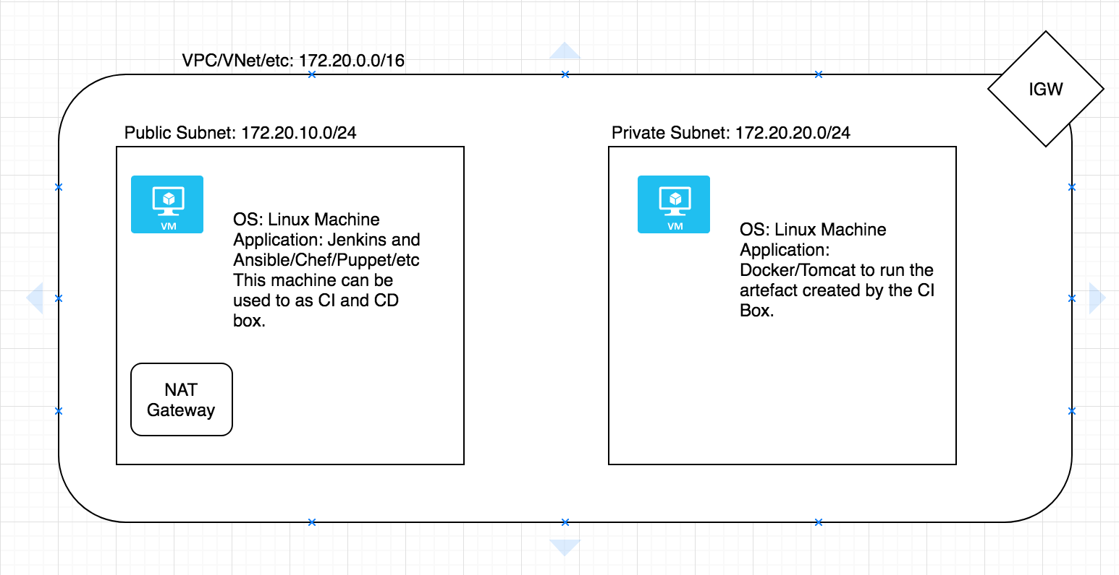

Statement 1: Using any IaC frameworks (Terraform/ARM/CFT) create the same infra that is depicted above. You will also need to use the userdata to install the Jenkins and Ansible/Chef/Puppet/etc.

Statement 2: From Jenkins create the artefact as Dockerfile/War/Jar file and store it locally (/mnt/artefact)

Statement 3: Now using the ansible/Puppet/Chef, deploy the same artefact (/mnt/artefact/..) to the box that is in the private subnet.

Note: In case you are using Docker, please use the Public Docker Hub to store the Docker Image.

Once you complete, share the code via any SCM (GitHub/GitLab/etc)